Rainbow

Shining light through a prism can make a rainbow.
The colours of a rainbow make a ‘spectrum of light’.

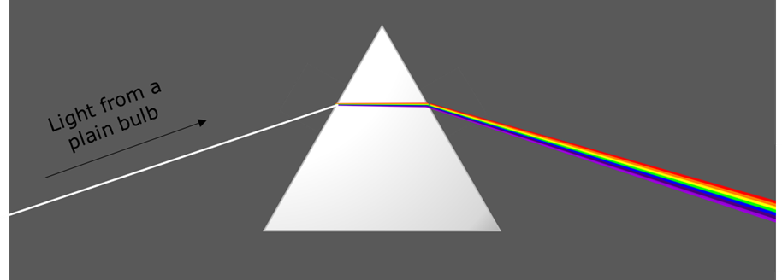

Where do the colours of the rainbow come from?
Put a tick (✓) in the box next to the best answer.

A | The prism makes the light sparkle because it is shiny
B | The prism adds colours to the light
C | The prism reacts with the light and changes its colour
D | The prism splits up the colours that the light is made of

Physics > Big idea PSL: Sound, light and waves > Topic PSL2: How we see > Key concept PSL2.2: Seeing in colour
Diagnostic question
Rainbow

Overview
Learning focus: | Daylight and sunlight are made from all the colours of the spectrum, which together we see as ‘white light’.
Observable learning outcome: | Explain how daylight / sunlight can be split into colours of the spectrum, whereas yellow light cannot.
Question type: | Simple multiple choice
Key words: | Prism, spectrum

What does the research say?
For a physicist, sunlight and daylight are both examples of white light. Each consists of all the colours of the spectrum which combine to be seen as white. Students often regard white light as ‘pure light’ that is free of any tinge. More than half of a sample of 13- to 16-year-olds (n=166) considered colour to be different to light and something that is added to light (Galili and Hazan, 2000).
When asked why red light is seen to come from a red filter, Zylbersztajn and Watts found that about half of a sample of 150 13-year-olds thought that white light was changed in some way by the filter and a sixth of the sample suggested the light had been dyed in some way. These students were questioned shortly after being taught about colour. (Driver et al., 1994; Zylbersztajn and Watts, 1982)
This question reminds students that a spectrum of colours can be made from white light. It then investigates where they think the colours come from, in order to check their understanding of how some colours of light, including daylight, are made from a combination of different colours.
NB In the text of this question the term ‘white light’ is not used. Instead the light is described as from a plain bulb, and can be further described as light similar to daylight. It is helpful to avoid the term ‘white light’ at this stage and to focus instead on developing a scientifically sound concept of the nature white light which is related to everyday experiences. The term ‘white light’ is introduced later to label this kind of light. (Haagen-Schutzenhofer, 2017)
Ways to use this question
Students should complete the question individually. This could be a pencil and paper exercise, or you could use an electronic ‘voting system’ or mini white boards and the PowerPoint presentation.
The answers to the question will show you whether students understood the concept sufficiently well to apply it correctly.
If there is a range of answers, you may choose to respond through structured class discussion. Ask one student to explain why they gave the answer they did; ask another student to explain why they agree with them; ask another to explain why they disagree, and so on. This sort of discussion gives students the opportunity to explore their thinking and for you to really understand their learning needs.
Differentiation
You may choose to read the questions to the class, so that everyone can focus on the science. In some situations it may be more appropriate for a teaching assistant to read for one or two students.
Equipment
For the class (optional):
- A large prism and bright light source to show a spectrum of light
Expected answers
D, the prism splits up the colours that the light is made of.
How to respond - what next?
Answers B and C are likely to be fairly common responses that are wrong.
If students have misunderstandings about whether the prism has reacted with the light or added something to it to give it colour, then it can help to challenge the students to explain what happens when one particular colour found in the spectrum is shone through the prism. If the prism reacts or adds something then another rainbow should be formed (and it is not). To investigate this further, the following BEST ‘response activity’ could be used in follow-up to this diagnostic question:
- Response activity: yellow light
Acknowledgments
Developed by Peter Fairhurst (UYSEG).
Images: Peter Fairhurst (UYSEG).
References
Driver, R., et al. (1994). Making Sense of Secondary Science: Research into Children's Ideas, London, UK: Routledge.
Galili, I. and Hazan, A. (2000). Learners' knowledge in optics: interpretation, structure and analysis. International Journal of Science Education, 22(1), 57-88.
Haagen-Schutzenhofer, C. (2017). Students' conceptions on white light and implications for teaching and learning about colour. Physics Education, 52.
Zylbersztajn, A. and Watts, D. M. (1982). Throwing some light on colour. Guildford: Mimeograph, University of Surrey.

